Notes: Create a Jira ticket for this assignment, work on the tasks listed below, and submit the task completion document by EOD with clear steps and required evidence (outputs/screenshots)
- Create a user with the name Techie and provide sudo access to the user.
- Navigate to the home directory.
- Create a new directory.
- List the contents of a directory.
- Change the current directory.
- Create a new empty file.
- View the contents of a file.
- Copy a file to another location.
- Move a file to another location.
- Rename a file.
- Delete a file.
- Grant or revoke permissions on a file or directory.
- View the current date and time.
- Check the system uptime.
- View the running processes.
- Kill a running process.
- Install a package using the package manager (e.g., apt or yum).
- Update the system packages.
- Create a symbolic link.
- Search for files using the find command.
- Compress and decompress files using tar.
- Monitor system resources with top or htop.
- Create and manage user groups.
- Set up SSH password less authentication.
- Monitor log files using tail or grep.
- Set up a web server (e.g., Apache or Nginx).
- Configure and secure a MySQL Database.
- Set up an Application Server (e.g.,Apache Tomcat)
- create a service file for Apache Tomcat.(Should execute by using systemtctl command)
- Print specific columns from a delimited file.
- Filter and print lines based on a specific pattern or condition.
- Calculate and print the average, sum, or other statistics of a column.
- Perform string manipulation, such as extracting substrings or changing case.
- Count the occurrences of a specific pattern in a file.
- Sort lines based on a specific field or column.
- Merge multiple files based on a common field or column.
- Substitute text in a file using search and replace.
- Delete specific lines based on a pattern or line number.
- Append or insert text before or after a specific pattern or line.
- Print only specific lines from a file.
- Copy file from linux to windows machine
- 5 use cases for AWK and 5 use cases for sed
1. Create a user with the name Techie and provide sudo access to the user.
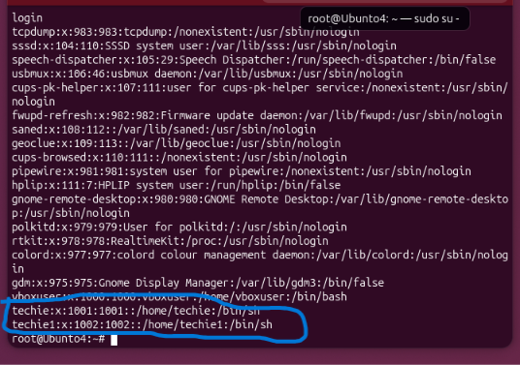
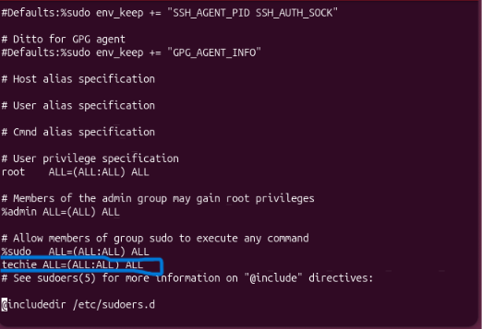
2.Navigate to the home directory.
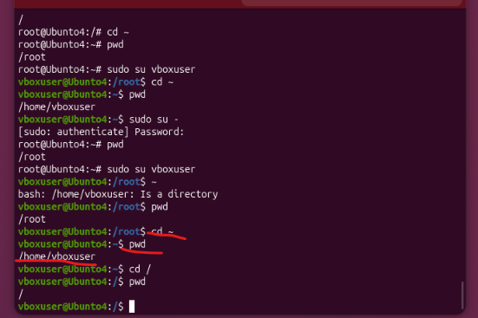
3. Create a new directory.
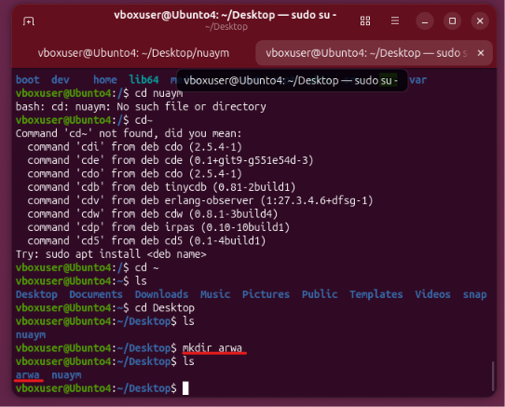
4. List the contents of a directory.
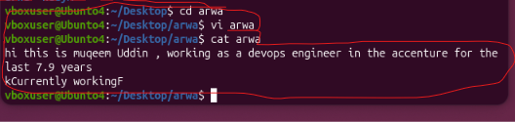
5. Change the current directory.
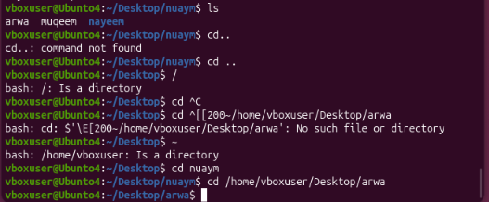
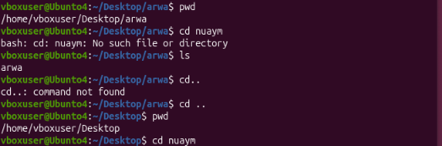
6. Create a new empty file.

7. View the contents of a file.
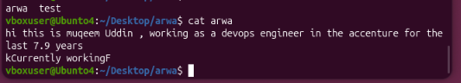
8. Copy a file to another location.
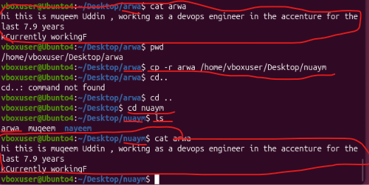
9. Move a file to another location.
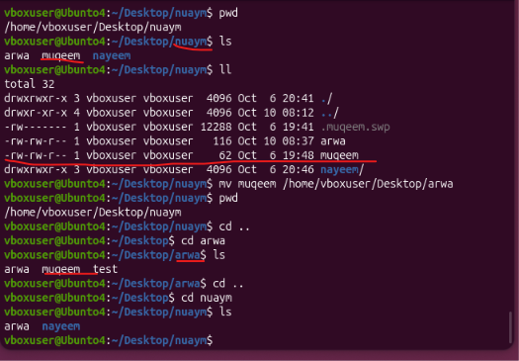
10. Rename a file.

11. Delete a file.
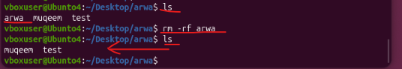
12. Grant or revoke permissions on a file or directory.
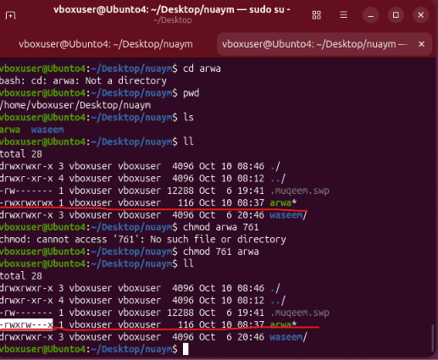
13. View the current date and time.
14. Check the system uptime.
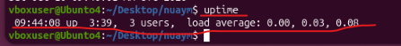
15. View the running processes.
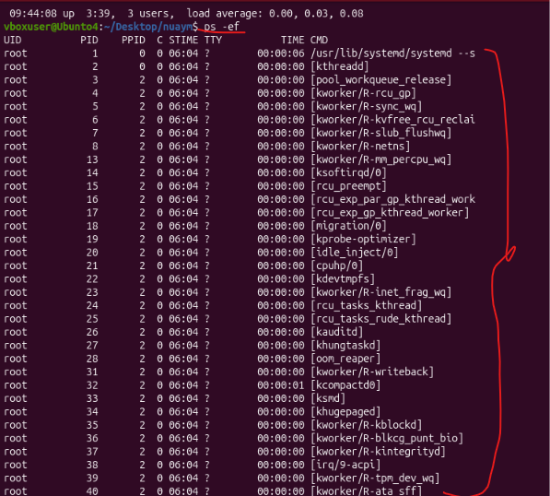
16. Kill a running process.
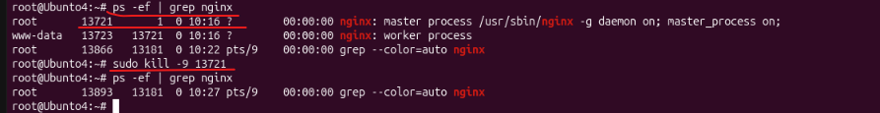
17. Install a package using the package manager (e.g., apt or yum).
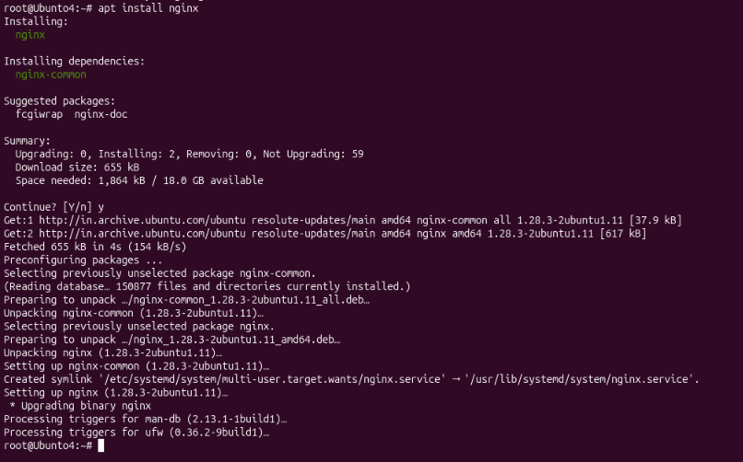
18. Update the system packages. :
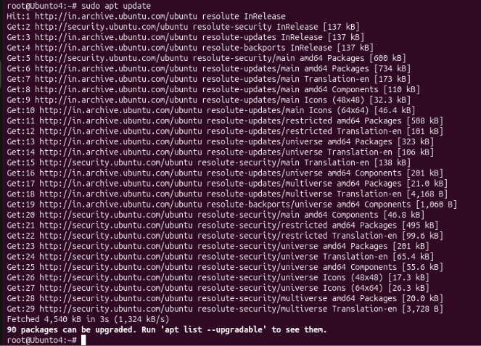
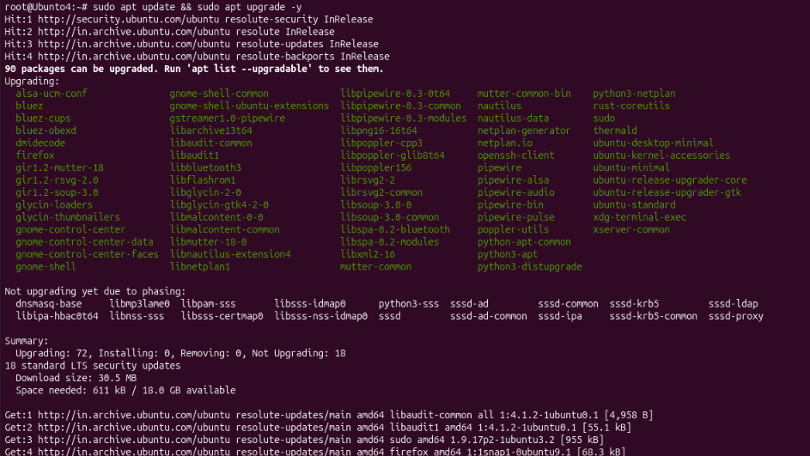
19. Create a symbolic link.
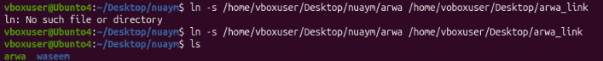
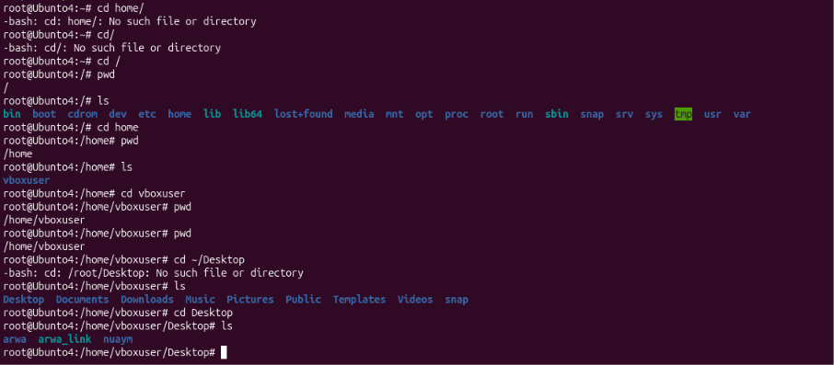
20.Search for files using the find command.
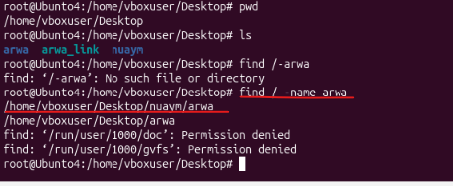
21. Compress and decompress files using tar.
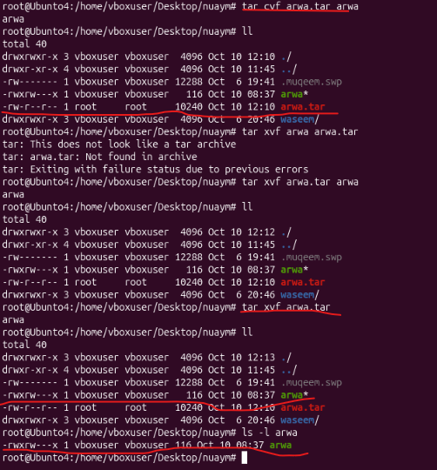
22. Monitor system resources with top or htop.
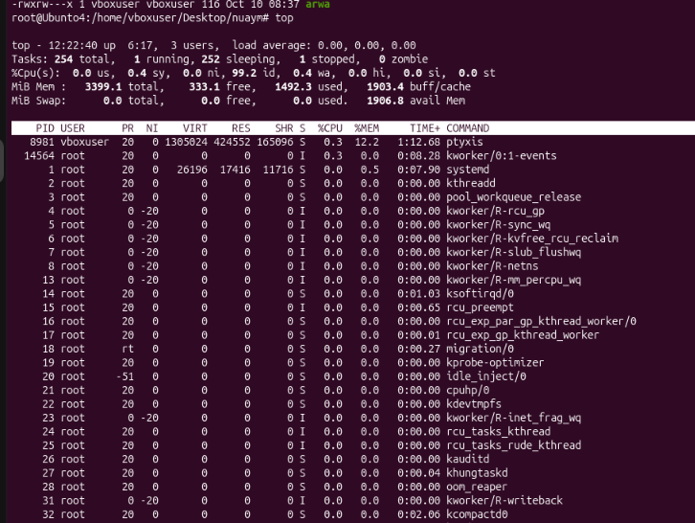
23. Create and manage user groups.
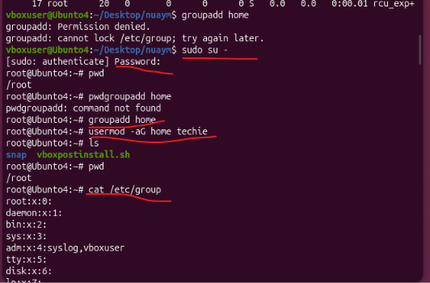

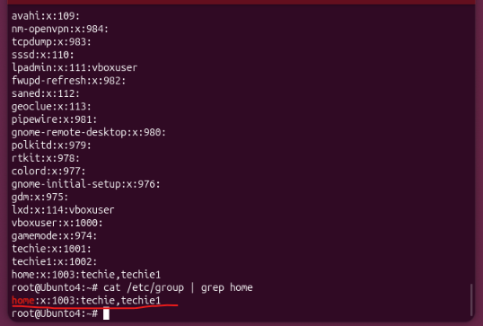
24. Set up SSH password less authentication.
First launch the Ec2 instance from AWS Console
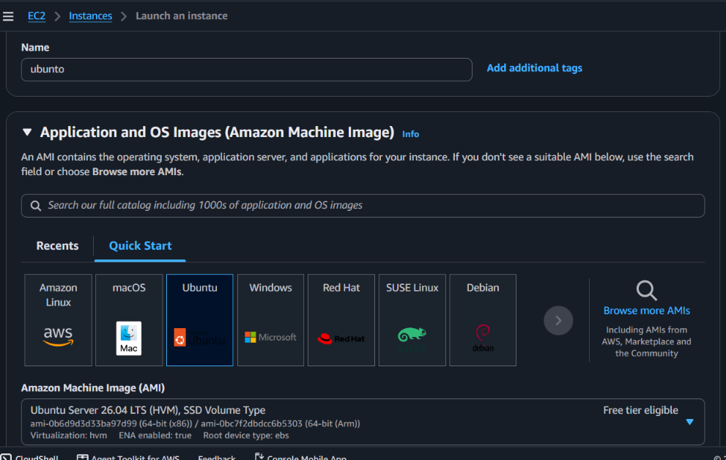
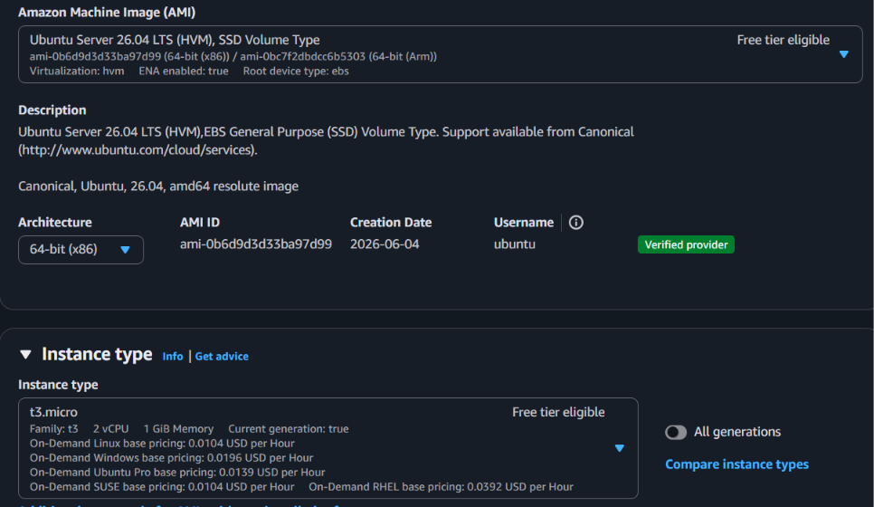
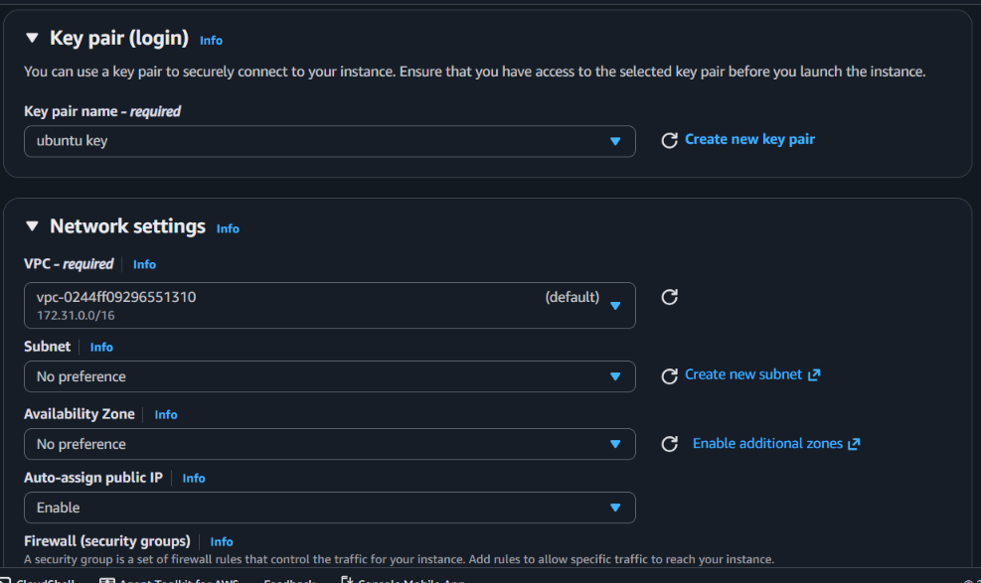
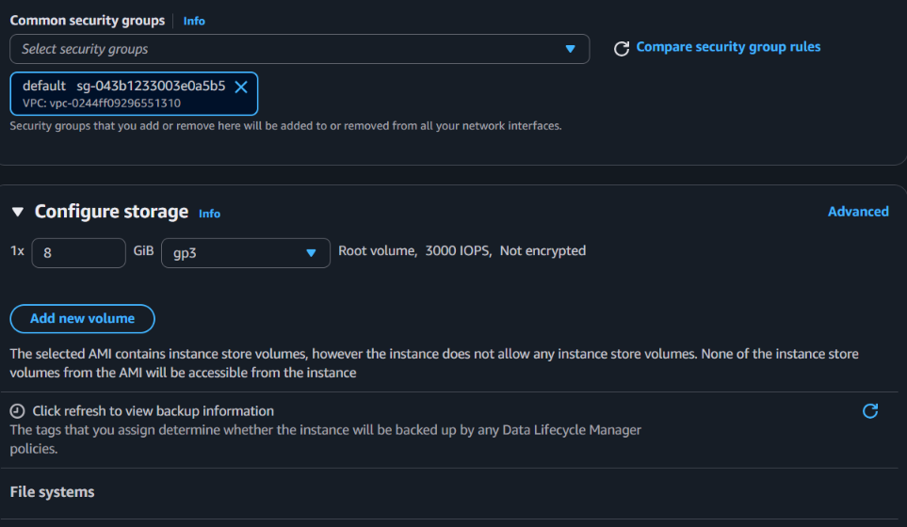
Configure the SSH port 22 with source 0.0.0.0/0
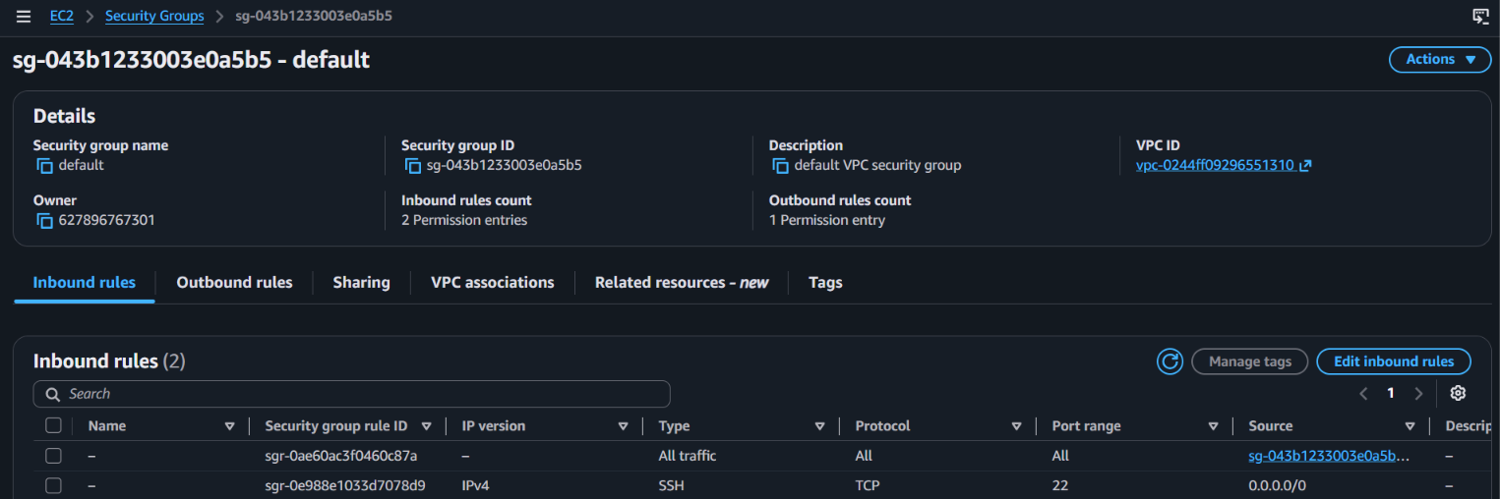
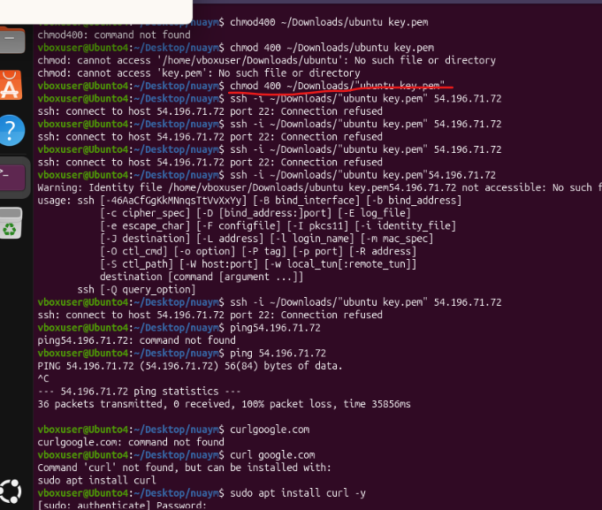
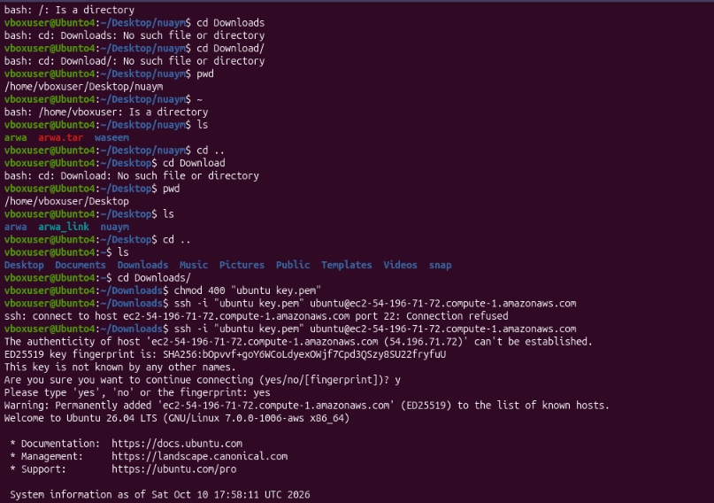
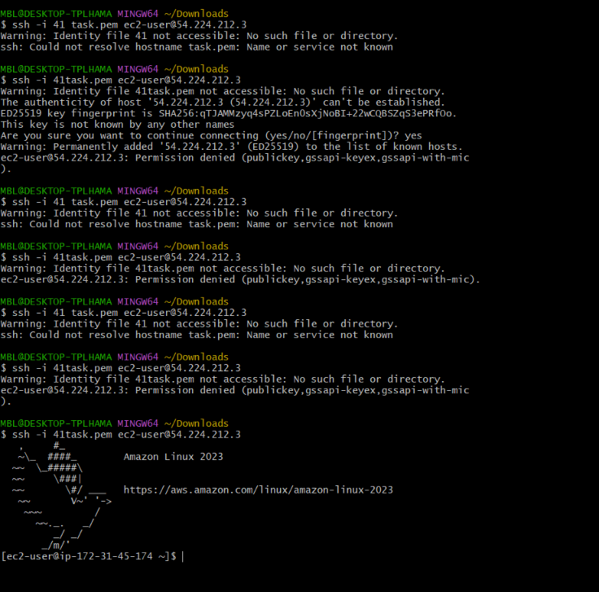
25. Monitor log files using tail or grep.
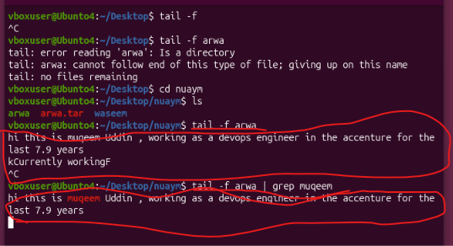
26. Set up a web server (e.g., Apache or Nginx).
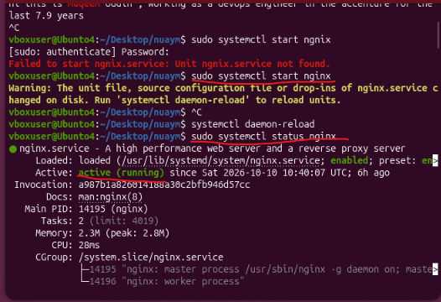
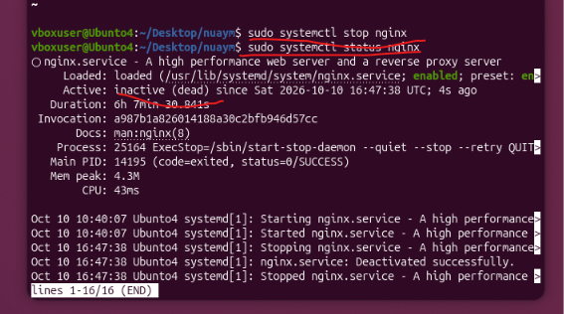
27. Configure and secure a MySQL Database.
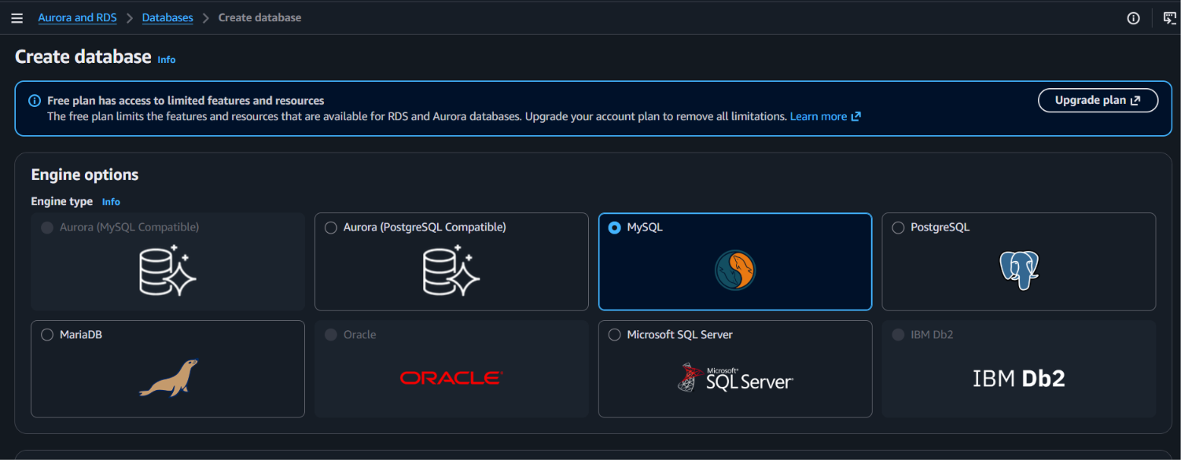
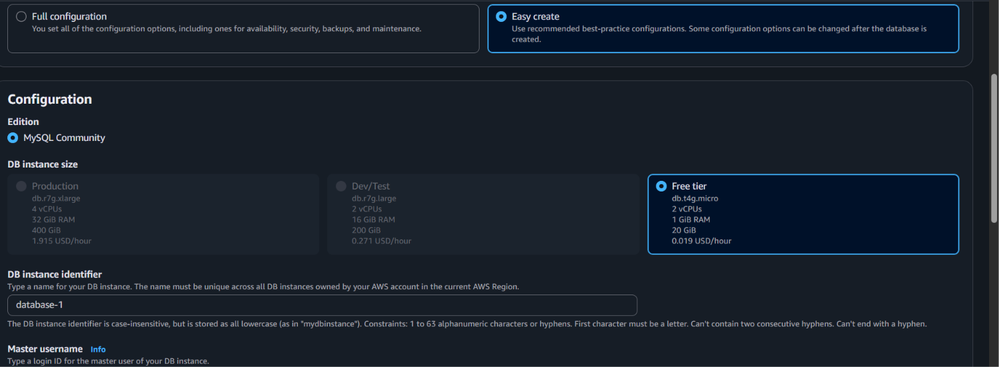
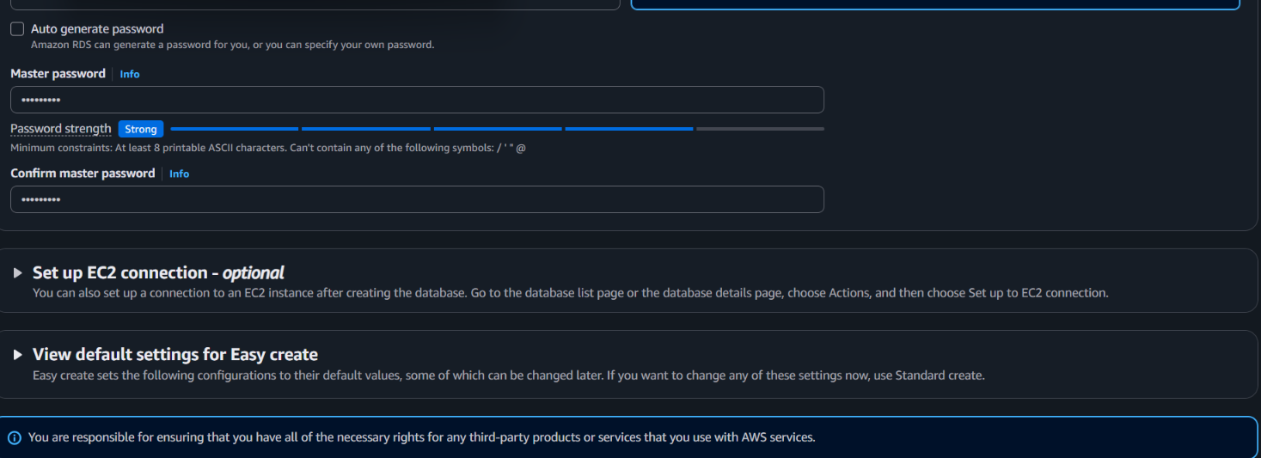
28 .Set up an Application Server (e.g.,Apache Tomcat)
I have downloaded the java through this command : sudo apt install default-jdk -y
Then give this command to go there so that i can download the tomcat in this location : cd /opt
Downloaded the apache tomcat through the link
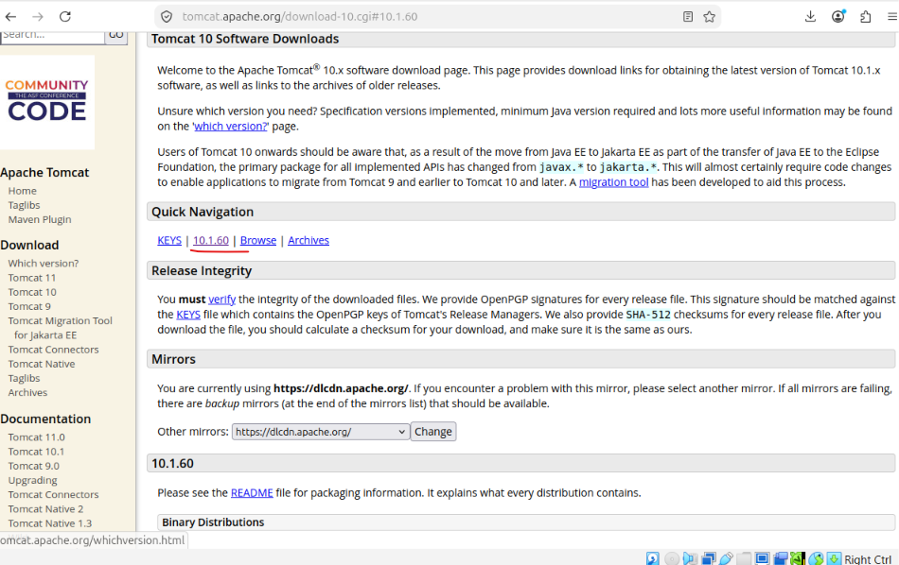
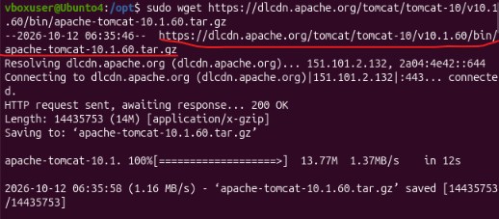
Then extract the compressed tomcat file to run on my system otherwise it’ll no open
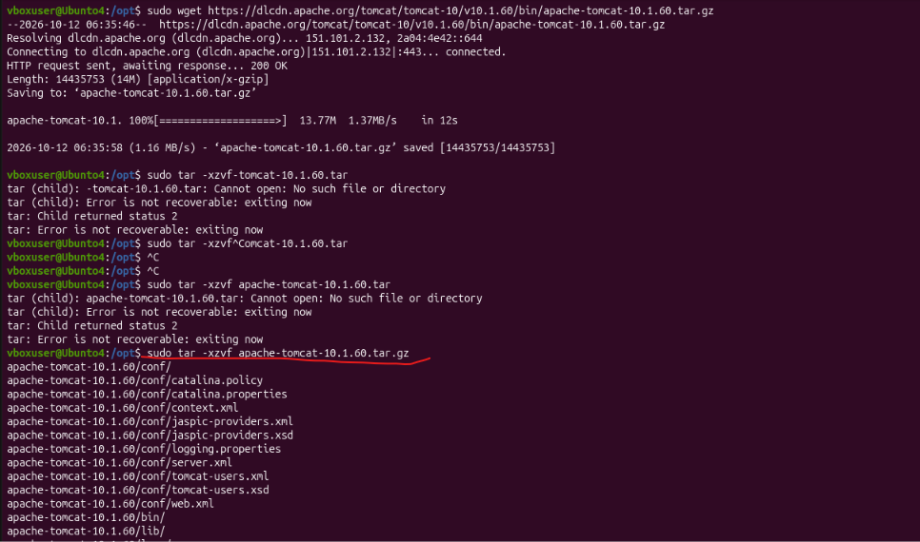
29. create a service file for Apache Tomcat.(Should execute by using systemtctl command)
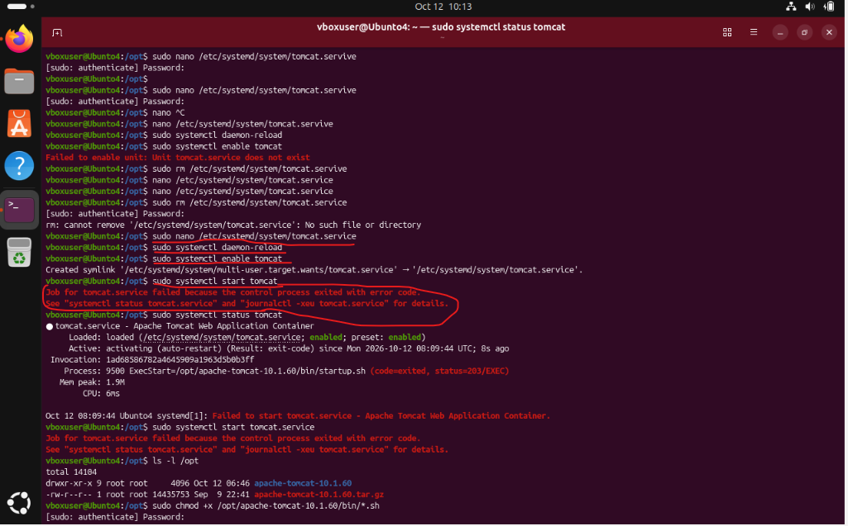
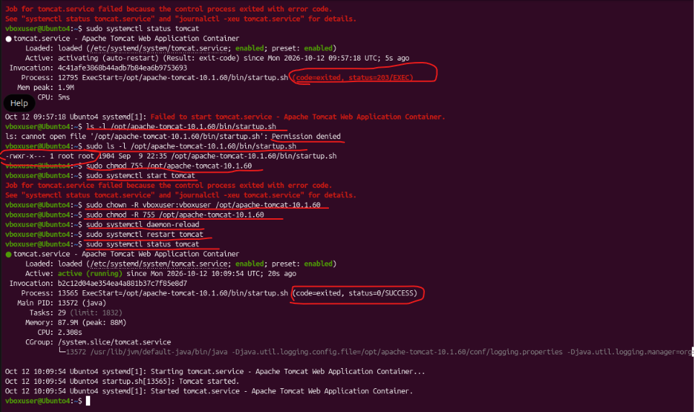
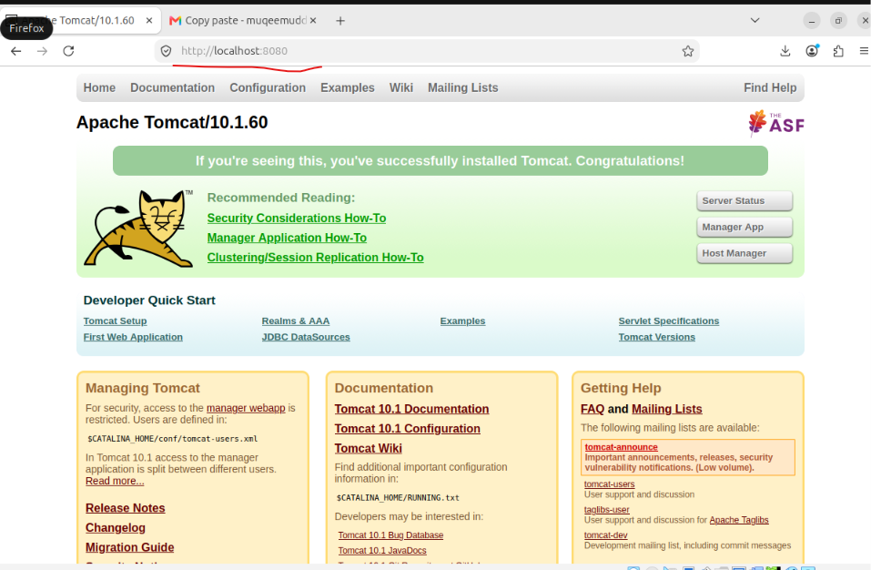
30. Print specific columns from a delimited file.
Created a file with 3 columns (field)
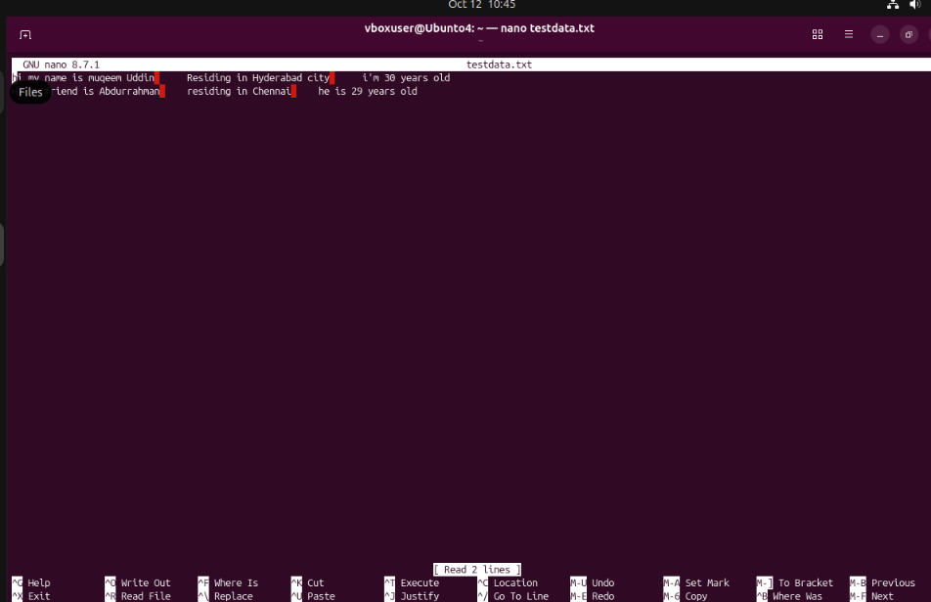
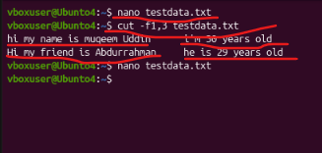
31. Filter and print lines based on a specific pattern or condition.
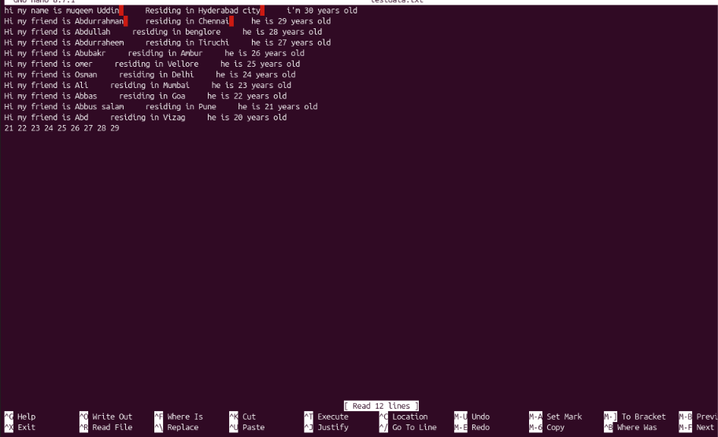
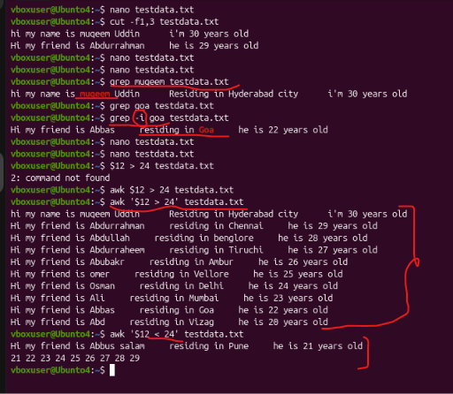
32. Calculate and print the average, sum, or other statistics of a column.
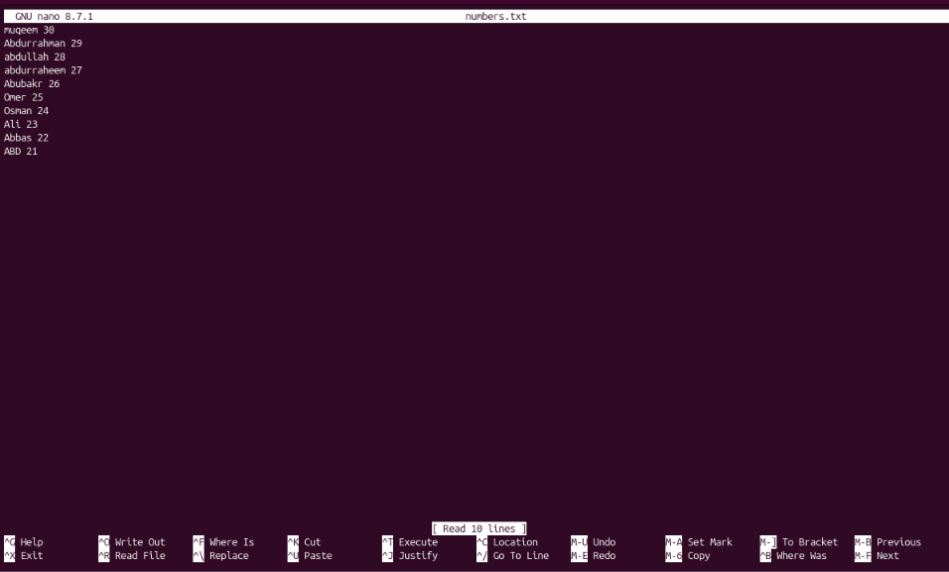
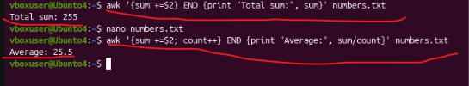
33. Perform string manipulation, such as extracting substrings or changing case.
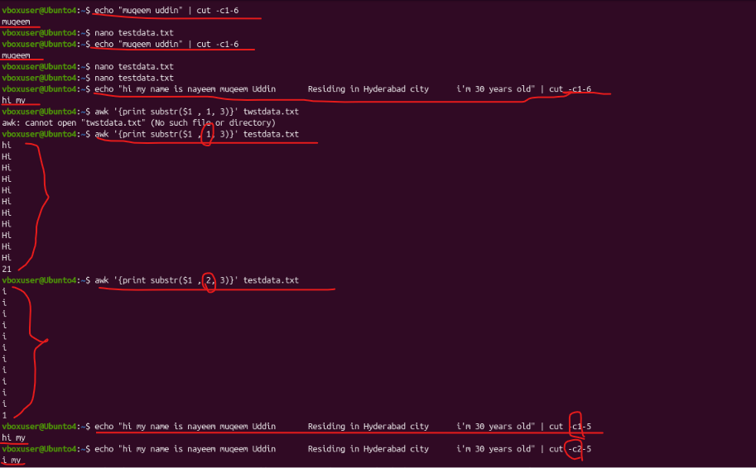
34. Count the occurrences of a specific pattern in a file.
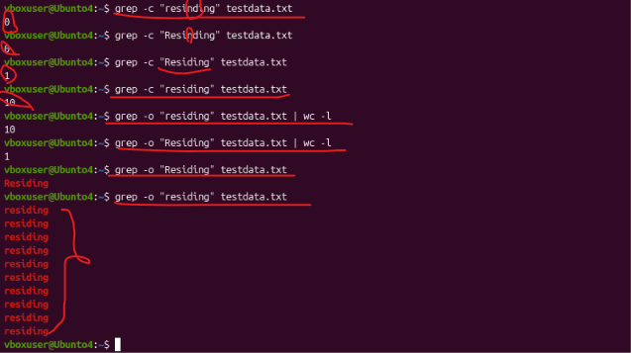
35. Sort lines based on a specific field or column.
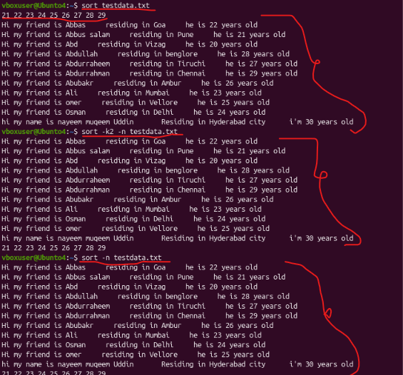
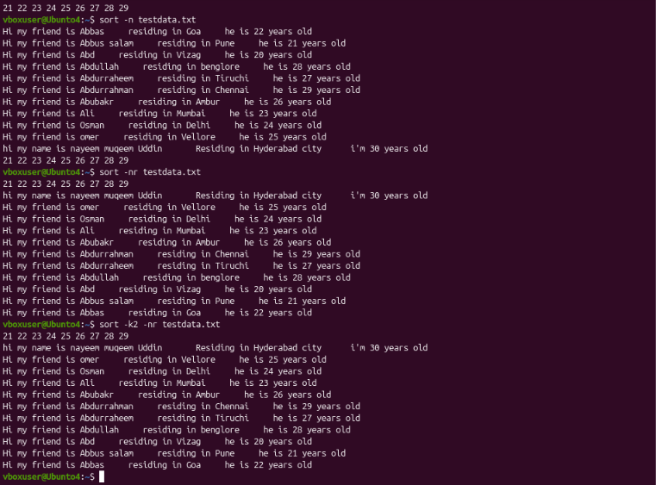
36. Merge multiple files based on a common field or column.
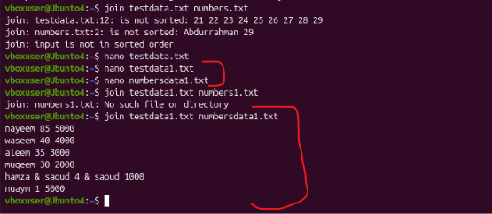
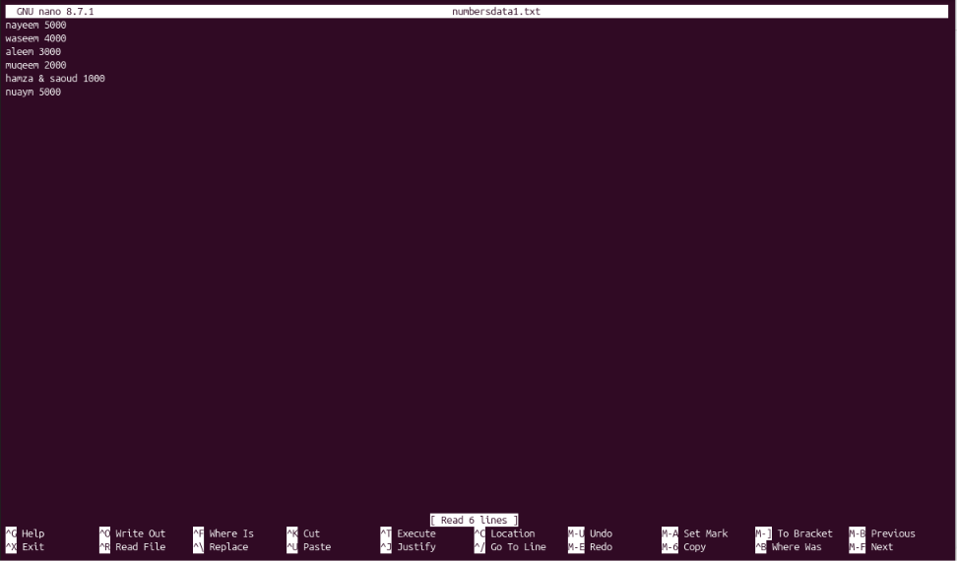

37. Substitute text in a file using search and replace.
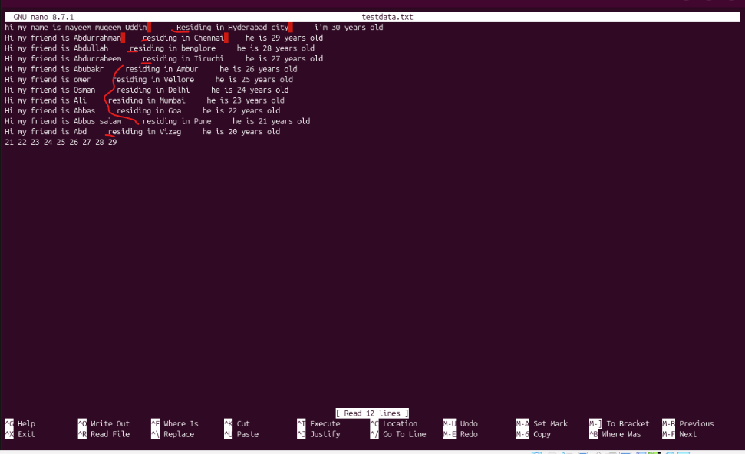
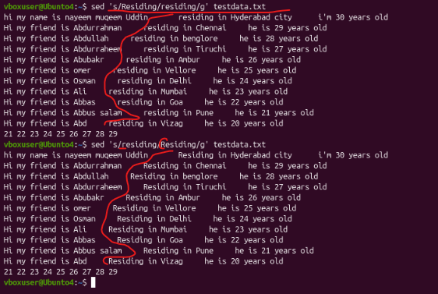
38. Delete specific lines based on a pattern or line number.
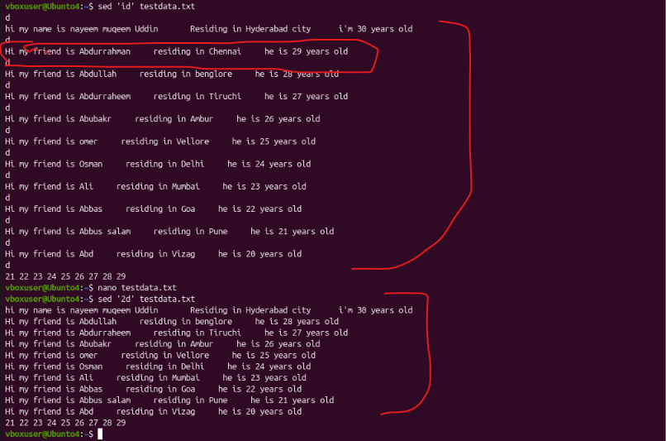
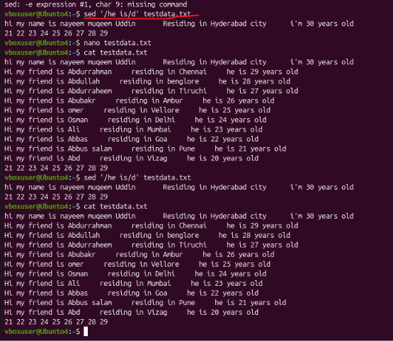
39. Append or insert text before or after a specific pattern or line.
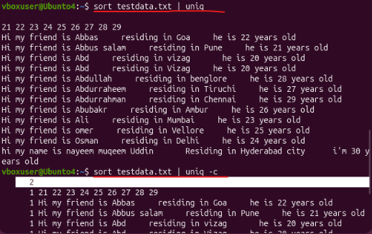
40. Print only specific lines from a file.
Got errors
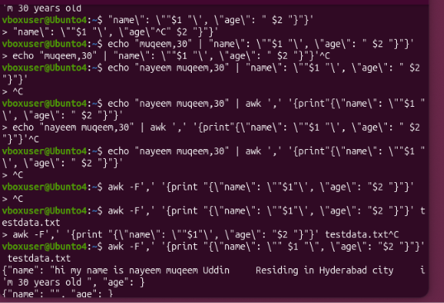
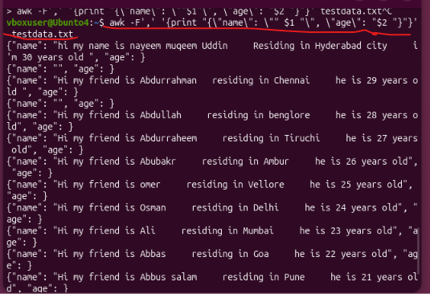
41.Copy file from linux to windows machine
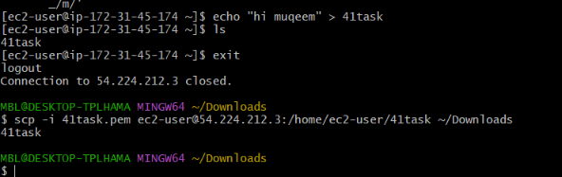
42. 5 use cases for AWK and 5 use cases for sed
AWK
Sed

